DEBUT AUTHOR RELEASES CAUTIONARY TALE

IN NEW BOOK “FROM 8,000 MILES”

Destiny Dawn Harris  251-215-9302  Destinydawnofficial@gmail.com  Destinydawnofficial.com | FOR IMMEDIATE RELEASE

A TRUE STORY NEVER BEFORE TOLD

One Family’s Trauma of Internet Danger and How Their Daughter was Saved

MOBILE, ALABAMA, November 11, 2024- Destiny Dawn Harris recounts the details of the trauma her family experienced in September 2018 when their twenty-one-year-old daughter left their home in the middle of the night headed to the other side of the world to meet an online stranger she had been communicating with for two years without her parents’ knowledge. Destiny tells their story to help bring awareness to families about online predators and to help save girls’ lives and those who may be caught in a similar trap. The book is available purchase exclusively on AMAZON here:
https://www.amazon.com/dp/B0DJ8T7G2B

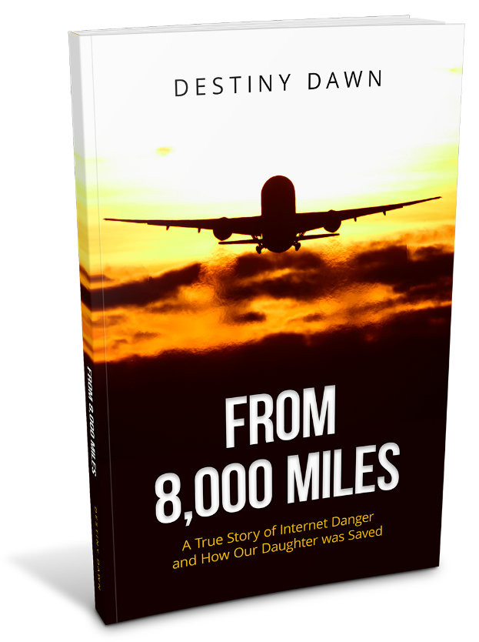 “A MUST READ FOR FAMILY AWARENESS”

The online stranger’s father paid for a one-way ticket to fly The Harrises’ daughter, Victoria, (not her real name) from her home in Alabama to their country of India. Victoria leaving her family, her dream job, her boyfriend, and her whole life behind portrays how skilled and deceptive online manipulators are. It is a business and anyone can be the target.

With the help of Homeland Security, U.S. Marshals sent by Congressman Bradley Byrne’s office, and others, The Harrises’ were able to rescue their daughter and bring her back safely to the U.S. but she was angry with them as she didn’t perceive the danger she was in, and it has now been over six years since she has contacted her parents. The Harrises’ still aren’t sure what the true intentions of the online stranger and his family were, whether it was an attempt at human trafficking or using their daughter to gain U.S. citizenship. To their knowledge, their daughter married the man and he arrived in the U.S. in January of this year and headed straight to Chicago without ever having contact with their daughter once reaching the U.S.

This book is a must read for families and shows what can happen when our children choose to trust a stranger over the ones who know them and love them best.

Destiny Dawn Harris is the mother of a daughter and two grown sons and lives in her hometown of Mobile, Alabama. She graduated from the University of South Alabama with a Bachelor of Science in Business Administration and owns and runs an automotive business with her husband, Brent, they founded in 1999. From 8,000 Miles is her first book. An outreach spurred from this experience and she started a You Tube channel where she discusses topics from the book including warning signs of predators and invites mothers to share their pain and wisdom to help each other through difficult situations with their children to bring hope and healing.

Read the Amazon Reviews here. Book Trailer, Teaser Trailer, Social Media Ad with Author Photo. For more information please visit Destinydawnofficial.com, Facebook Destiny Dawn Author Page, YouTube @DestinyDawnOfficial, and Amazon Author Page.

The publisher of the book is Triumph Press founder Melanie Davis. Melanie is dedicated to helping people publish and market their books and specializes in stories of Tragedy to Triumph.

